**Proposal for Hedge Fund Database Subscription**

**1. What do we need the database for?**

We want to use our alternative beta analysis framework to screen the broad hedge fund universe and then bring in potentially skillful managers for further due diligence. We have developed the capability to systematically analyze hedge fund returns, separating alpha from beta. The natural next step is to feed the system with data from a large number of hedge funds.

Therefore we need to subscribe one or more hedge fund databases.

**2. Main products on the market**

Following are the commonly used hedge fund databases:

* HFR database
* BarclayHedge HF Database
* Lipper Hedge Fund Database (TASS)
* Morningstar CISDM Hedge Fund database
* Preqin Hedge Fund database
* Eurekahedge hedge fund database
* HedgeFund Intelligence database

There is no legal requirement for hedge funds to report performance to the general public. Reporting to a hedge fund database is completely voluntary for the hedge fund managers. There are lots of differences in funds coverage, geographic coverage, strategy, and AUM reporting among the database products.

**3. Top Candidates: HFR, TASS, Morningstar**

Among the various databases, HFR database, TASS database, and Morningstar database are the most widely acknowledged and used products.

* **HFR database**

Hedge Fund Research, Inc. (HFR) is the global leader in the alternative investment research industry. Established in 1992, HFR specializes in the areas of indexation and analysis of hedge funds. The licensed/redistributed HFR Database, currently comprises over 7,000 funds and fund of funds, while the HFR Dead Fund Database includes over 15,000 funds. HFR Database is the foundation for the HFRI Indices, the industry's most widely utilized benchmark of hedge fund performance information.

* **Lipper TASS database**

Lipper, a Thomson Reuters company, is a global leader in supplying fund information, analytical tools, and commentary. Their global database has been a reliable source of timely, high-quality hedge fund data for over 20 years. Lipper Hedge Fund Database, also called the TASS database, offers quantitative performance data on over 5,000 actively reporting hedge funds and fund of hedge funds, plus over 16,000 graveyard funds that have closed, liquidated or stopped reporting for any reason.

* **Morningstar database**

Morningstar, Inc. is a leading provider of independent investment research in North America, Europe, Australia, and Asia. Morningstar’s hedge fund database contains data on over 8,000 actively reporting funds. Additionally, Morningstar offers historical information on more than 12,000 dead hedge funds.

**4. Recommendation: Subscribing to HFR Database**

We compared the above three “finalists” based on number of managers, active funds and dead funds, coverage of existing managers in our portfolio, pricing, AUM distribution, region distribution, and strategies distribution. Taking all of these aspects into consideration, we believe the HFR databases is the best choice.

Key reasons to choose HFR:

* **More coverage of $500mm+ managers**

The majority of hedge fund managers reporting to those databases have lower than $100mm AUM. Those “micro-cap” managers are not suitable for PRIM as our typical investment size is $100mm or more. We noticed that HFR database covers the highest number of managers with AUM of $500mm+, which is the most suitable manager size for PRIM.

* **Only HFR provide constituent data for the HFR Indices**

HFR Database is the foundation for the HFRI Indices, the industry's most widely utilized benchmark of hedge fund performance information. HFR Database contains complete, enhanced HFR Index constituent tables. Subscribers can drill down into components of the Industry's most widely-sourced performance benchmarks for further analysis.

* **Healthy distribution by strategy type**

HFR has the lowest % in Fund of Funds, which is the least useful category for PRIM. HFR also has the highest % in Relative Value and Macro funds, which are the most diversifying strategy types to the PRIT fund.

**Appendix**

**Managers and Active Funds**

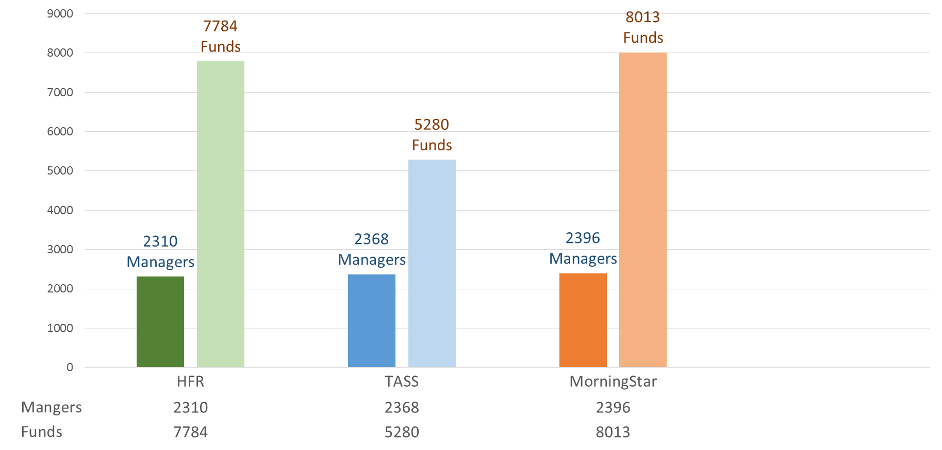

**Dead Funds**

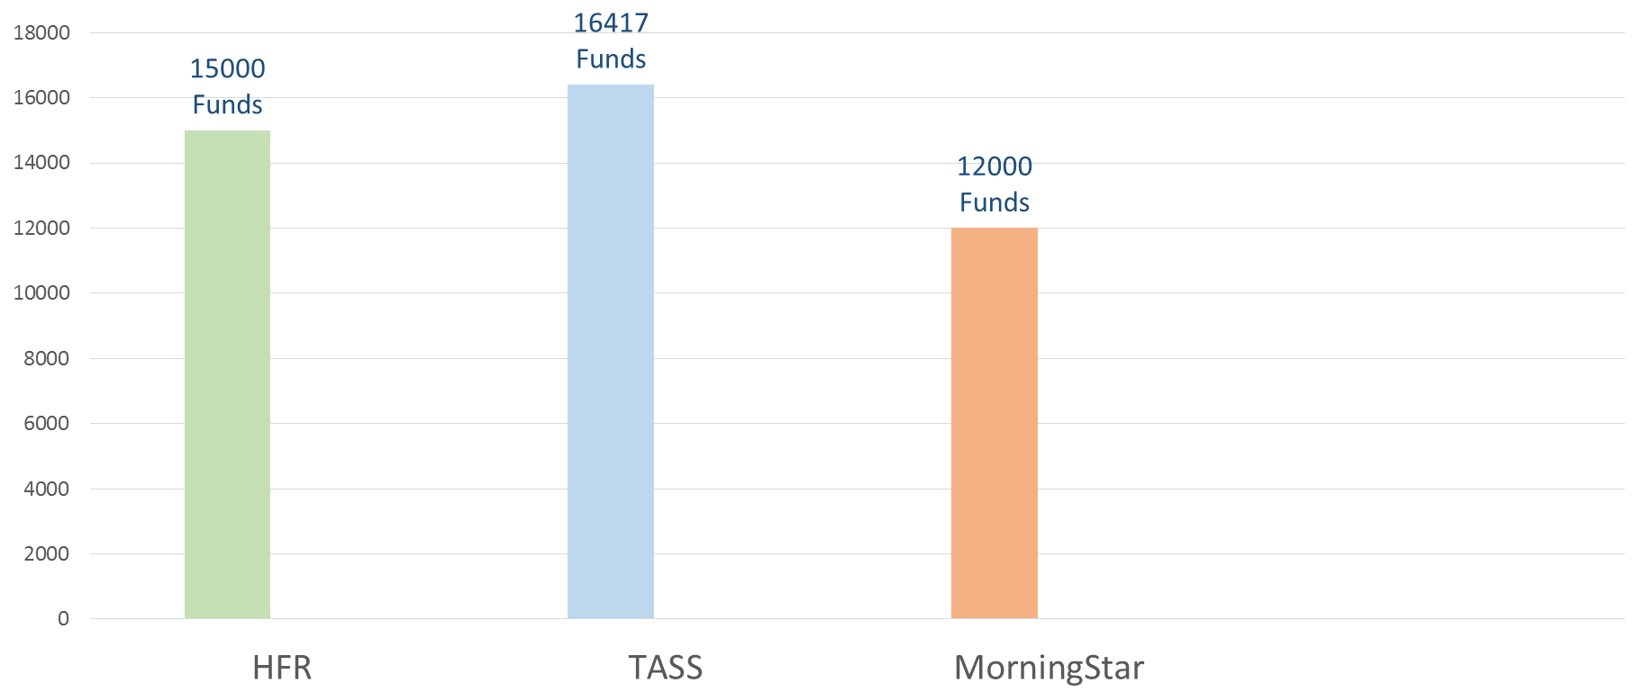

**Coverage of existing managers**

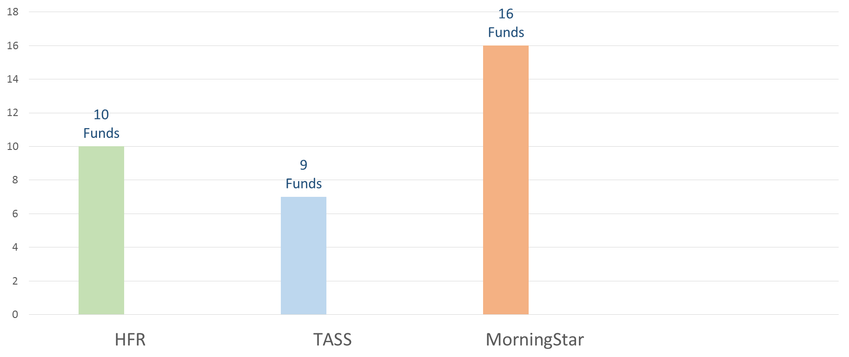

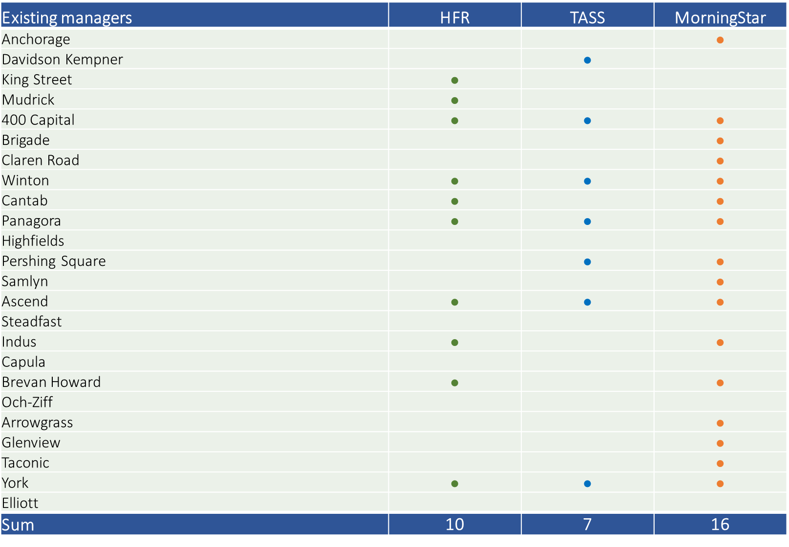

**Managers Overlap**

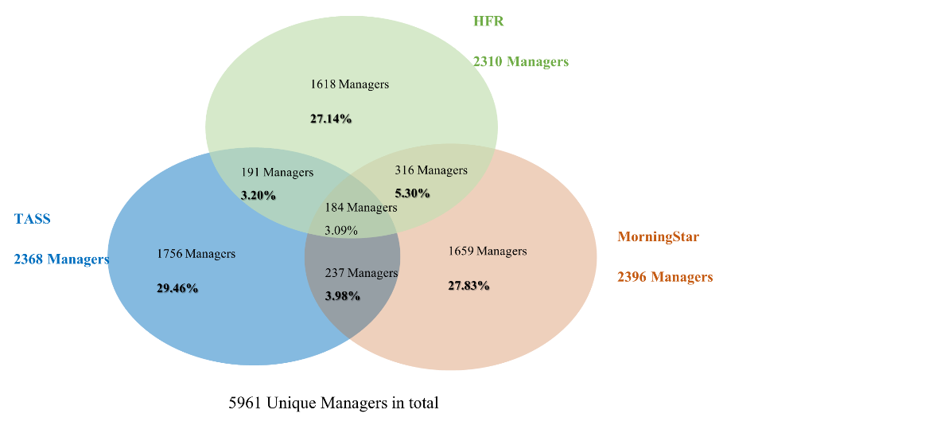

**Pricing**

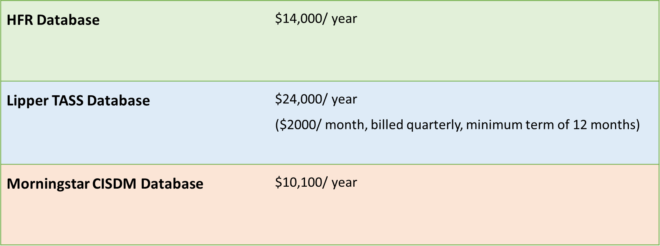

**AUM distribution**

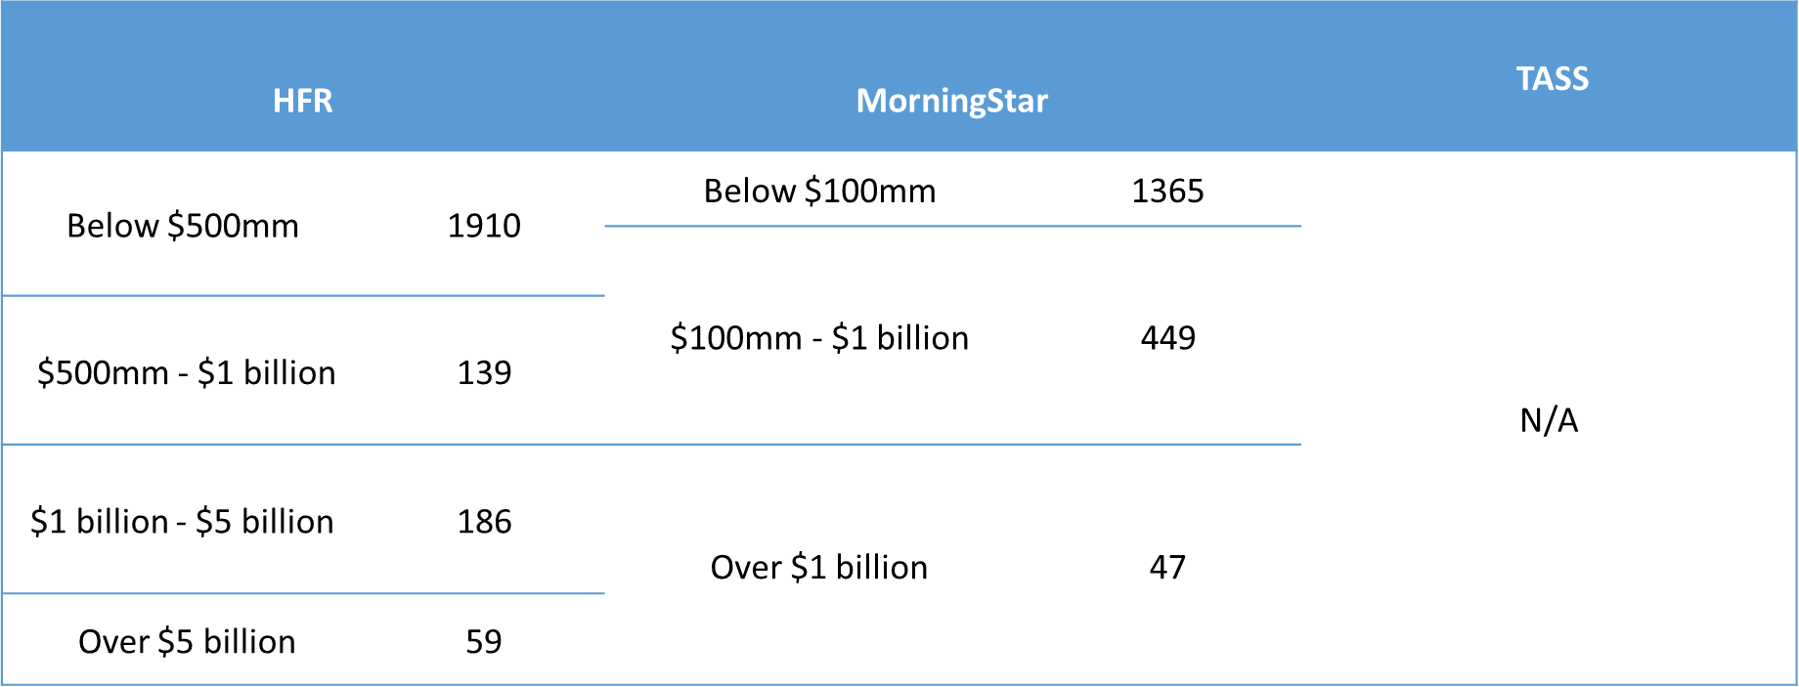

**Strategies distribution**

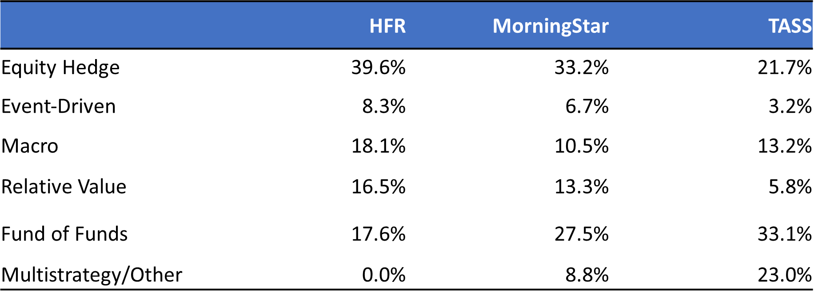

**Region distribution**

